Analysis Artifacts for Use Case 01 – Manage Members

**Table Of Contents**

Build ERD: Created by Kopal Shinde 2

2. Robustness Diagram: Created By Tejaswi Dasyam 3

3. Class Diagram: Created By Vaishali Jain 4

4. Sequence Diagram: Created By Mohanapriya Kottan Rajaraman 5

5. Communication Diagram: Created By Khushmeet Kaur 8

Add member: 8

6. State Diagram: Created By Tejaswi Dasyam 10

7. Data Flow Diagram: Created By Tejaswi Dasyam 11

8. Interface: Created By Tejaswi Dasyam 12

# 

# Build ERD: Created by Kopal Shinde

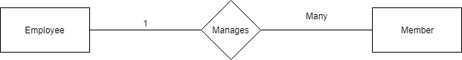

# 2. Robustness Diagram: Created By Tejaswi Dasyam

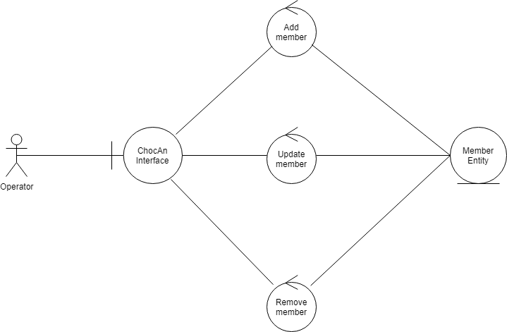

# 3. Class Diagram: Created By Vaishali Jain

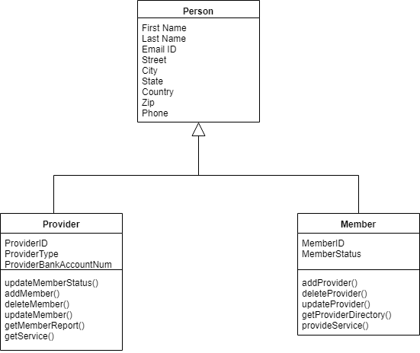

# 

# 

# 4. Sequence Diagram: Created By Mohanapriya Kottan Rajaraman

Add Member:

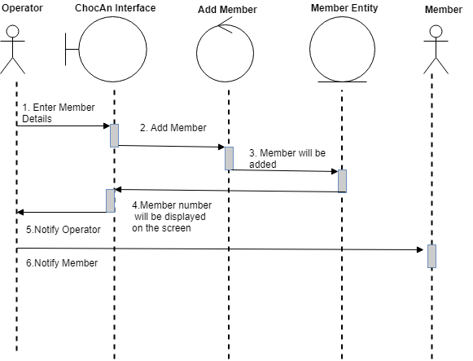

Delete Member:

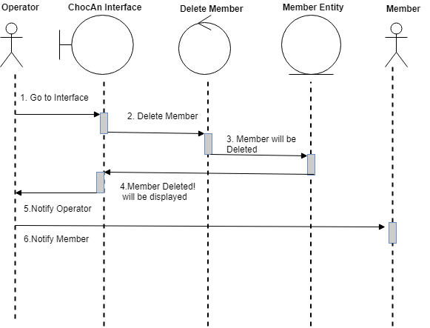

Update Member

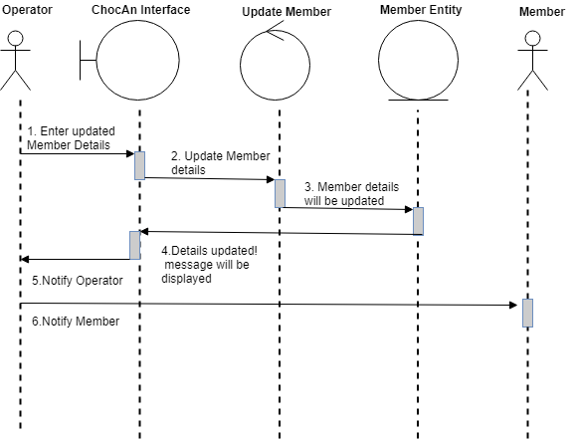

# 5. Communication Diagram: Created By Khushmeet Kaur

# Add member:

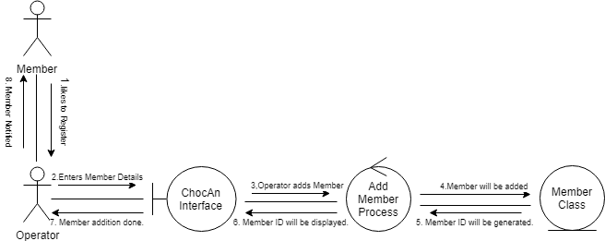

Delete Member:

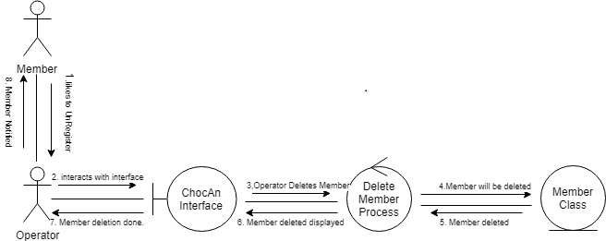

Update Member:

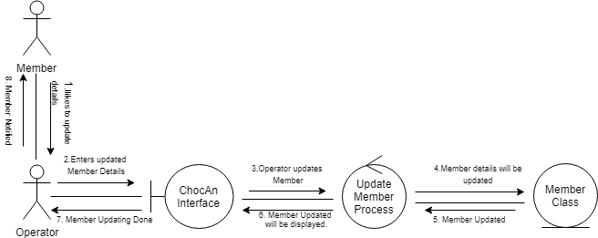

# 6. State Diagram: Created By Tejaswi Dasyam

Member State:

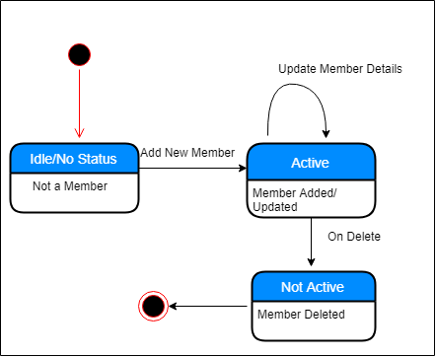

# 7. Data Flow Diagram: Created By Tejaswi Dasyam

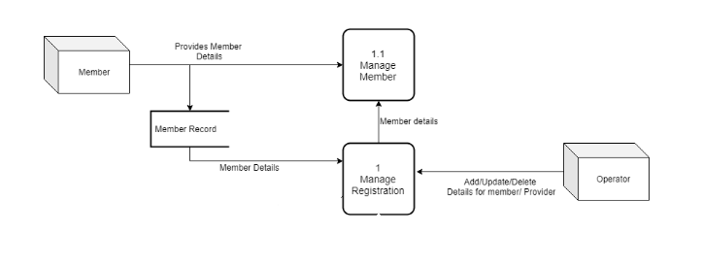

# 8. Interface: Created By Tejaswi Dasyam

Main Screen

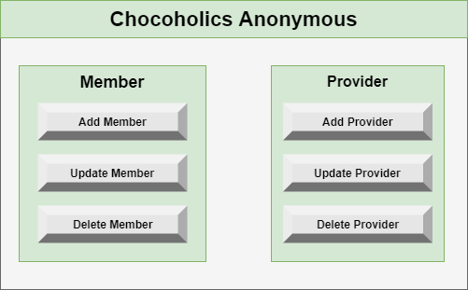

External Interface

